**Introduction:**

Housing price is one of the most important question that concerns people. With the rapid economic and population growth, more people are aspiring to have their own houses. However, price of apartment keeps fluctuating but the affective factors remain ambiguous.

The apartment price in Daegu in South Korea has been documented from 2007 to 2017. In the 10 year time frame it provides a long-term perspective on the crucial factors of apartment prices. The datasets gathered 29 potential factors and observations totaled over 1.4 million. In this project, we would first check the structure, dimensions, and attributes of the data set, and handle missing values. Then, we would conduct a correlation analysis to find out 6 most important features that influence the housing price. Also, we will rule out interrelated variables to avoid double counting. Next, we move to model prediction and compare the result of 4 different models. Finally, we will choose the best model with lowest RMSE and highest R2 value.

**Analysis:**

Import Data:

Using the read.csv() function, we loaded the data set into the python. The entire data set contains 5891 observations with 30 variables. We named the data set as “df”.

Data Structure:

We checked the data set structure using info() function. The result indicates that the class of the data set is data frame. The data set contains 5891 entries and 30 variables. It also showed the data type of each variable. Among the 30 variables, there are 8 integers, 6 objects and 16 floats. We consolidated the definition and type of each variable in the table below.

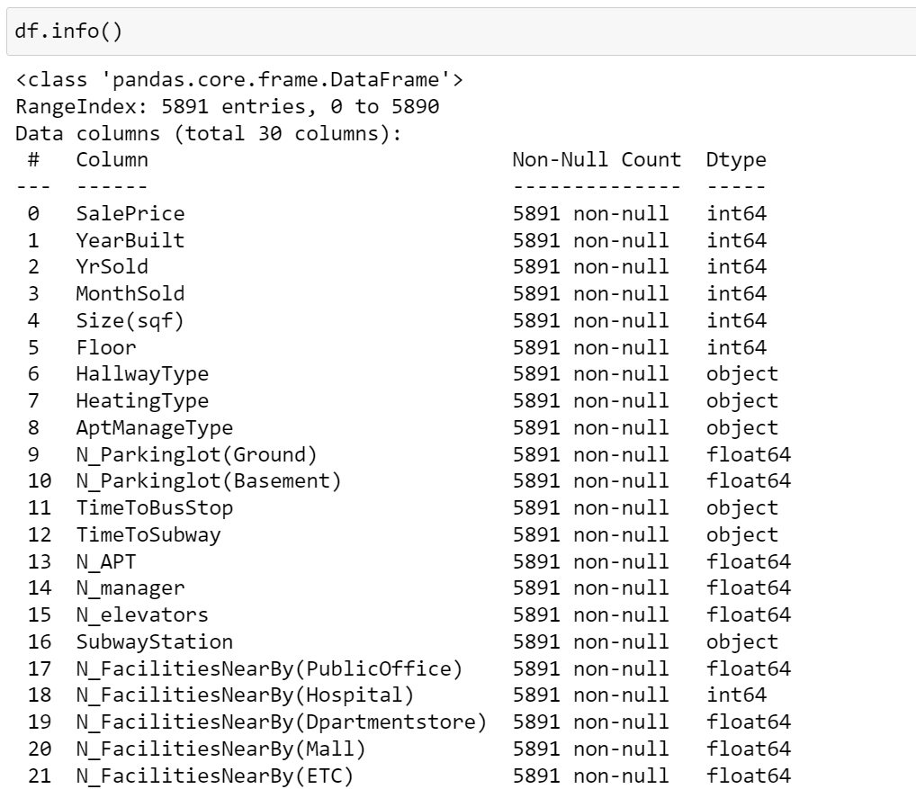

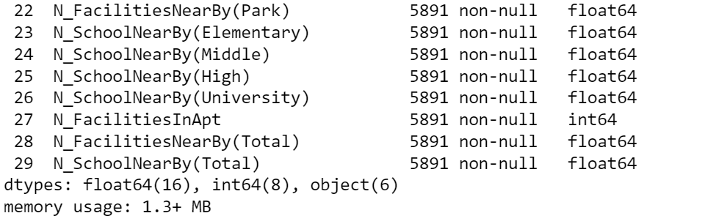

|  |  |  |
| --- | --- | --- |
| Name | Description | Type |
| SalePrice | Price in US dollar (target feature) | Integer |
| YearBuilt | The year that the apartment is built | Integer |
| YrSold | The year that the apartment is sold | Integer |
| MonthSold | The month that the apartment is sold | Integer |
| Size | size of apartment in square feet | Integer |
| Floor | what floor is property located | Integer |
| HallwayType | Terraced, corridor or mixed hallway | Object |
| HeatingType | Individual or central heating | Object |
| AptManageType | type of how apartment was managed by | Object |
| N_Parkinglot(Ground) | count number of parking spaces on the ground | Float |
| N_Parkinglot(Basement) | count number of parking spaces on basement | Float |
| TimeToBusStop | measure time takes from apartment to bus stop (categorical) | Object |
| TimeToSubway | measure time takes from apartment to subway station (categorical) | Object |
| N_APT | number of apartment building in a apartment complex | Float |
| N_manager | number of people manage apartment facilities (eg. security, cleaner etc) | Float |
| N_elevators | total number of elevators in an apartment complex | Float |
| SubwayStation | name of subway station nearby apartment | Object |
| N_FacilitiesNearBy(PublicOffice) | number of public offices nearby apartment | Float |
| N_FacilitiesNearBy(Hospital) | number of hospitals nearby apartment | Integer |
| N_FacilitiesNearBy(Departmentstore) | number of department stores nearby apartment | Float |
| N_FacilitiesNearBy(Mall) | number of malls nearby apartment | Float |
| N_FacilitiesNearBy(ETC) | like hotels, special school | Float |
| N_FacilitiesNearBy(Park) | number of parks nearby apartment | Float |
| N_SchoolNearBy(Elementary) | number of elementary schools nearby apartment | Float |
| N_SchoolNearBy(Middle) | number of middle schools nearby apartment | Float |
| N_SchoolNearBy(High) | number of high schools nearby apartment | Float |
| N_SchoolNearBy(University) | number of universities nearby apartment | Float |
| N_FacilitiesInApt | number of facilities for residents like swimming pool, gym, play ground | Integer |
| N_FacilitiesNearBy(Total) | total number of facilities nearby apartment | Float |
| N_SchoolNearBy(Total) | total number of schools nearby apartment | Float |

Missing Value:

Applying the isnull() function, we checked if there is any missing value in the dataset. It turns out that the count of null value is 0. In other words, the data is quite clean.

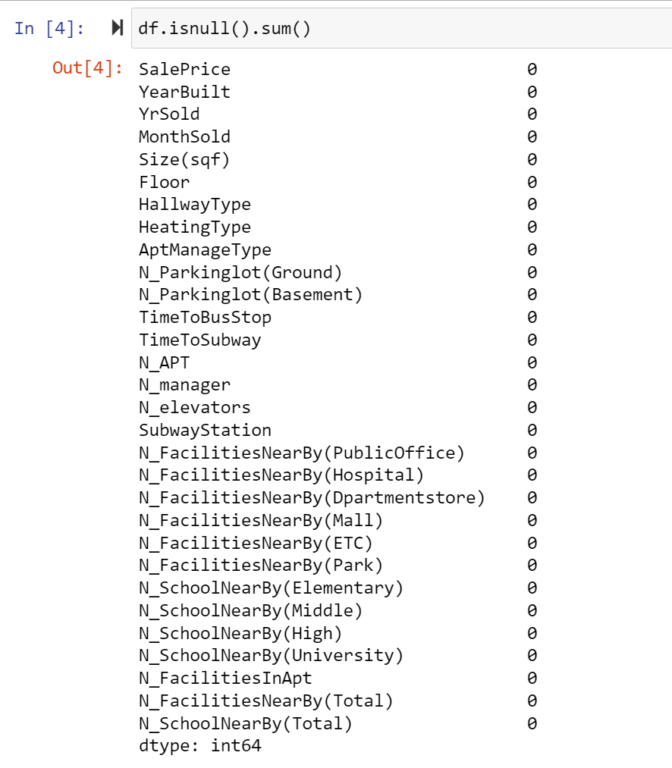

The next part of our project is data cleaning and choosing the most significant features among those 29 factors that can influence the housing price.

First, we transferred the categorical value to the numerical value. For example, the data uses the time taken to the subway and bus stations to represent the distance for residents. Thus, we transferred the different period groups to numbers, where the larger numbers mean closer to stops than small numbers.

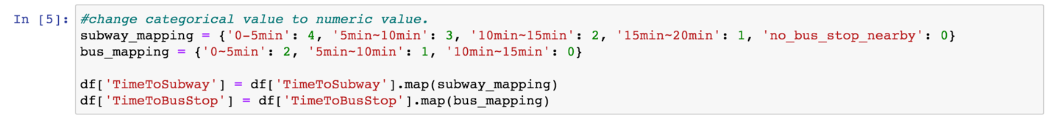

Our team plotted a heat map to look into the correlation between our data. The darker the color the closer the correlations. It is easy to understand the correlation = 1 in the diagonal line. We can also see some close correlations between some variables as well.



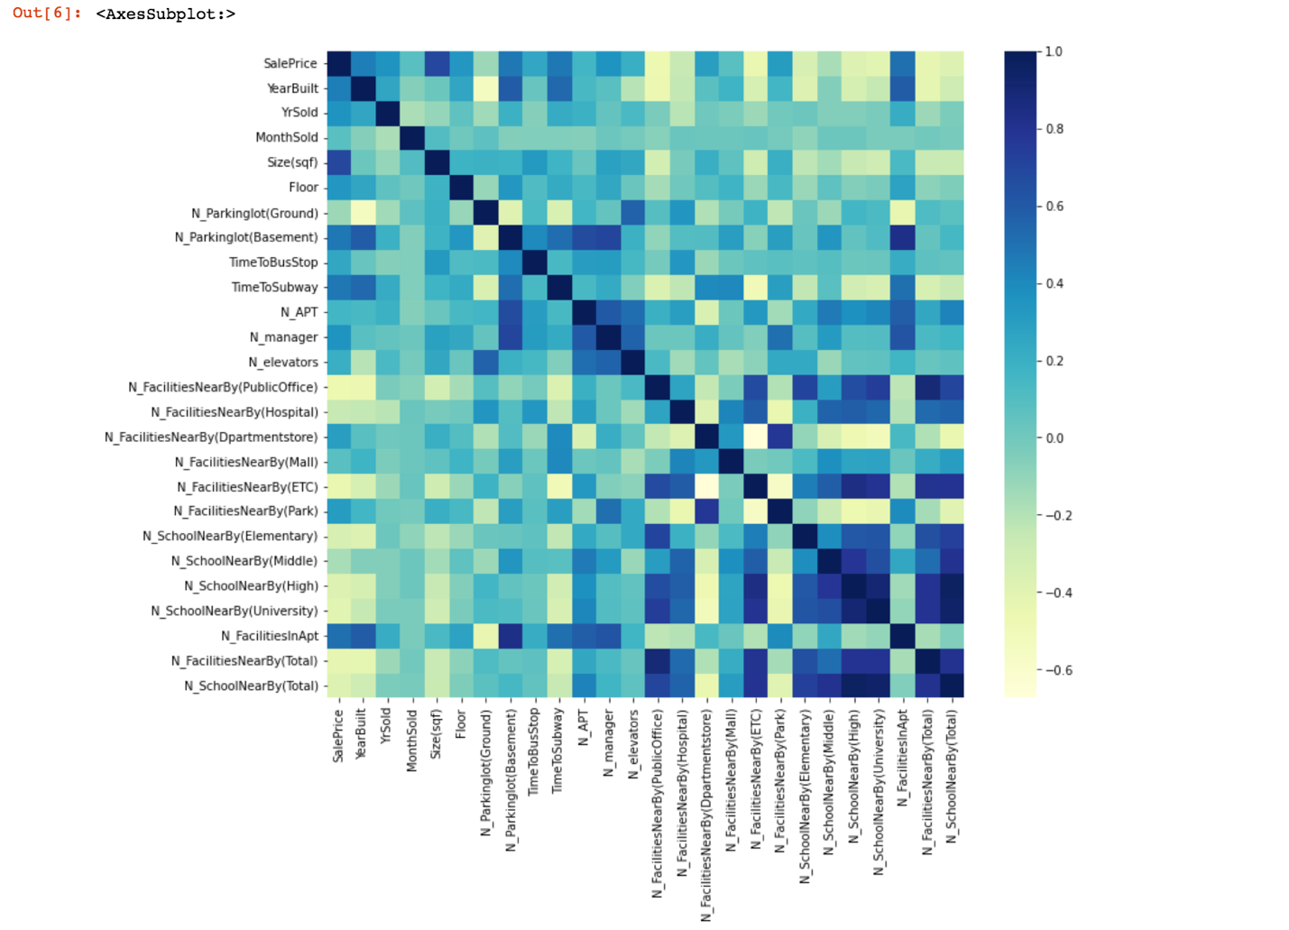

The bellowed table shows the correlations of each variable to the sales price. From the chart, we can find the size(sqft), and facilities in the apartment are the two most correlated factors, but almost all of the variables correlate with the price to a similar extent ranging (-0.5,0.5).

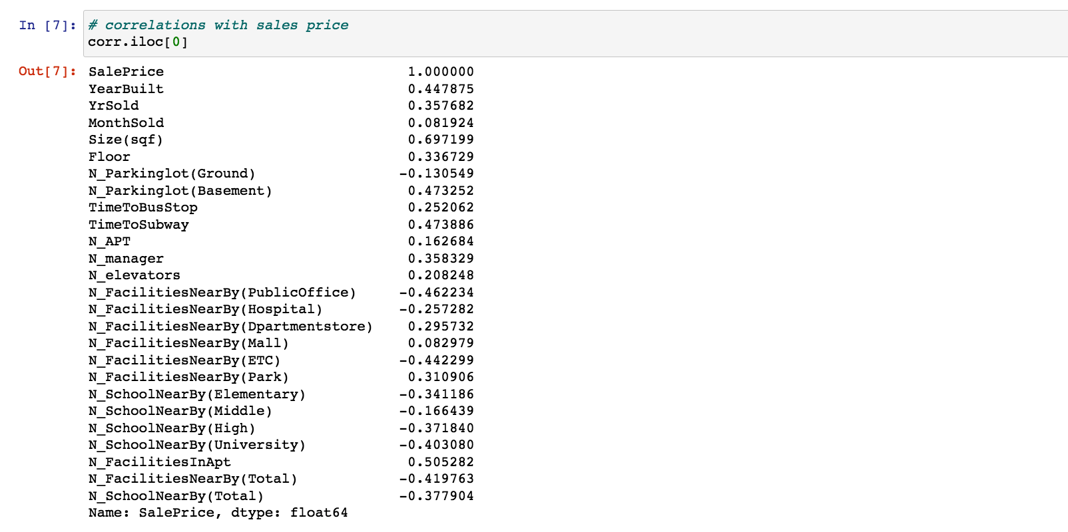

To make the model simple, we delete the features with word explanations like hallway, heating, and Apartment management types. And we included the previous transformed numerical distance factors and created a new data frame.

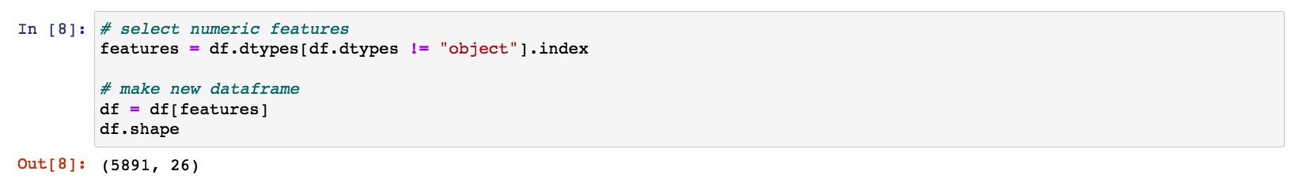

We select the dataset from the new data frame to create our X and Y in the regressions. Standardized X and split the X and Y into train set and test set with the proportion of 30%.

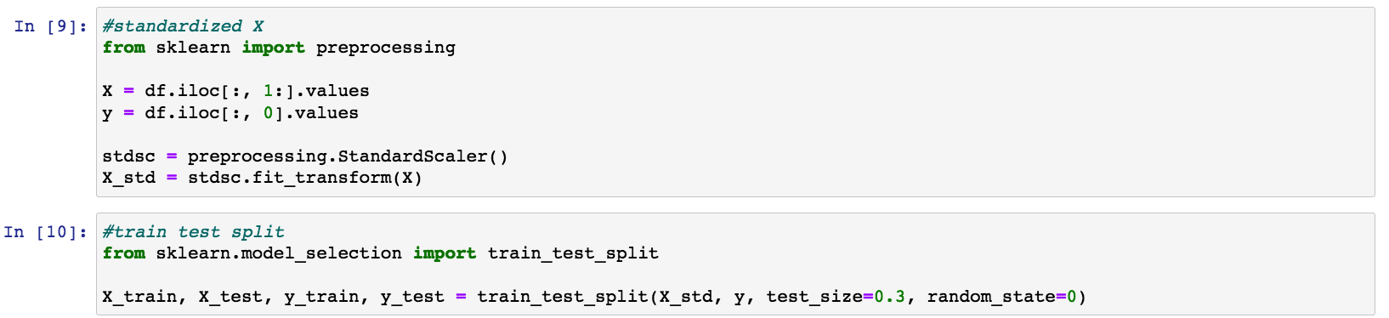

Next, we decided to use linear regression to first fit our model.

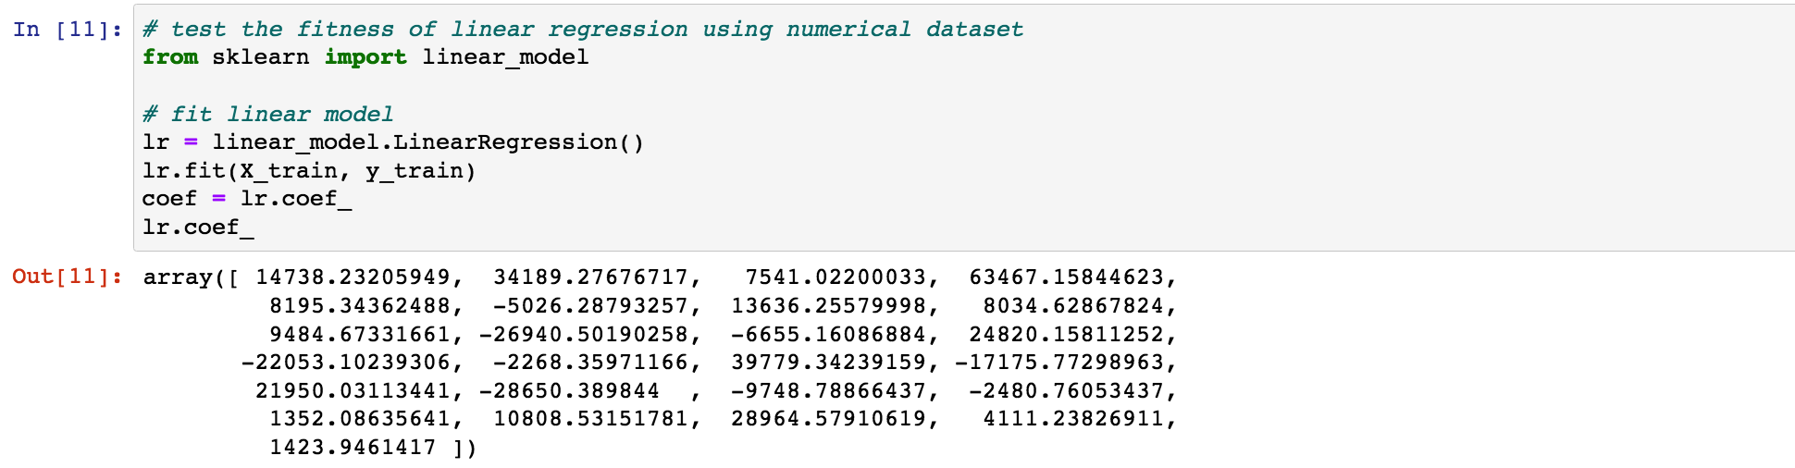

We use the graph to plot the result. The visualized table ranked the factors from most positively correlated to most negatively correlated.

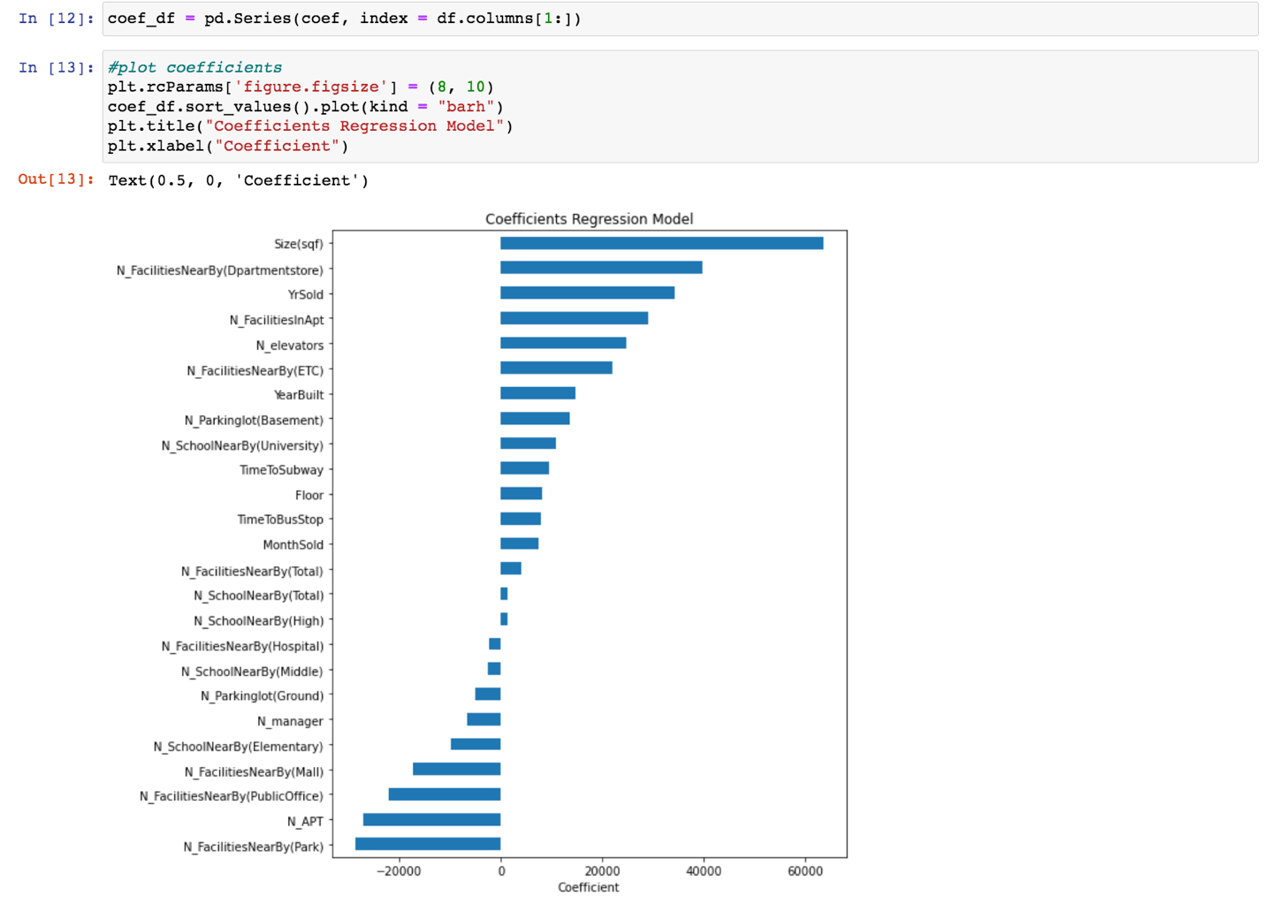

The RMSE calculated value of this linear regression is quite large and close to 39,277. We thought it might be due to outliers in data.

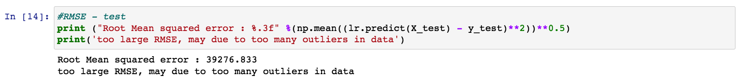

To make our model more accurate, we consider measuring those outliers in the following steps.

From the first graph plotted below, we can see that our data is right-skewed, which means there is some sales price extremely high that may influence the result of our model.

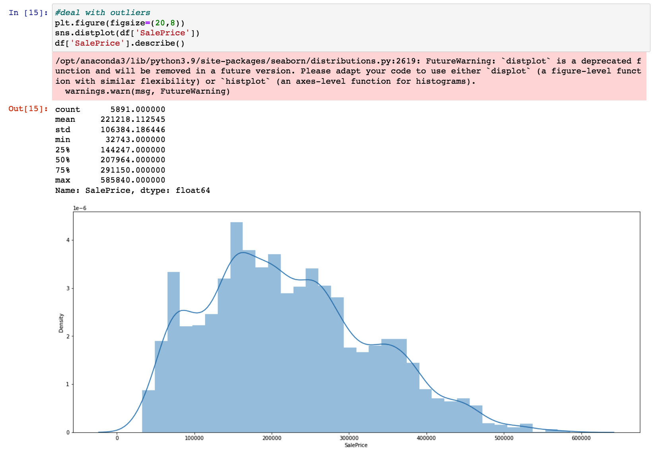

The second graph shown below is a method that can easily figure out which part of y is the outlier number. And we can get, that the value above 51,000 can be dropped.

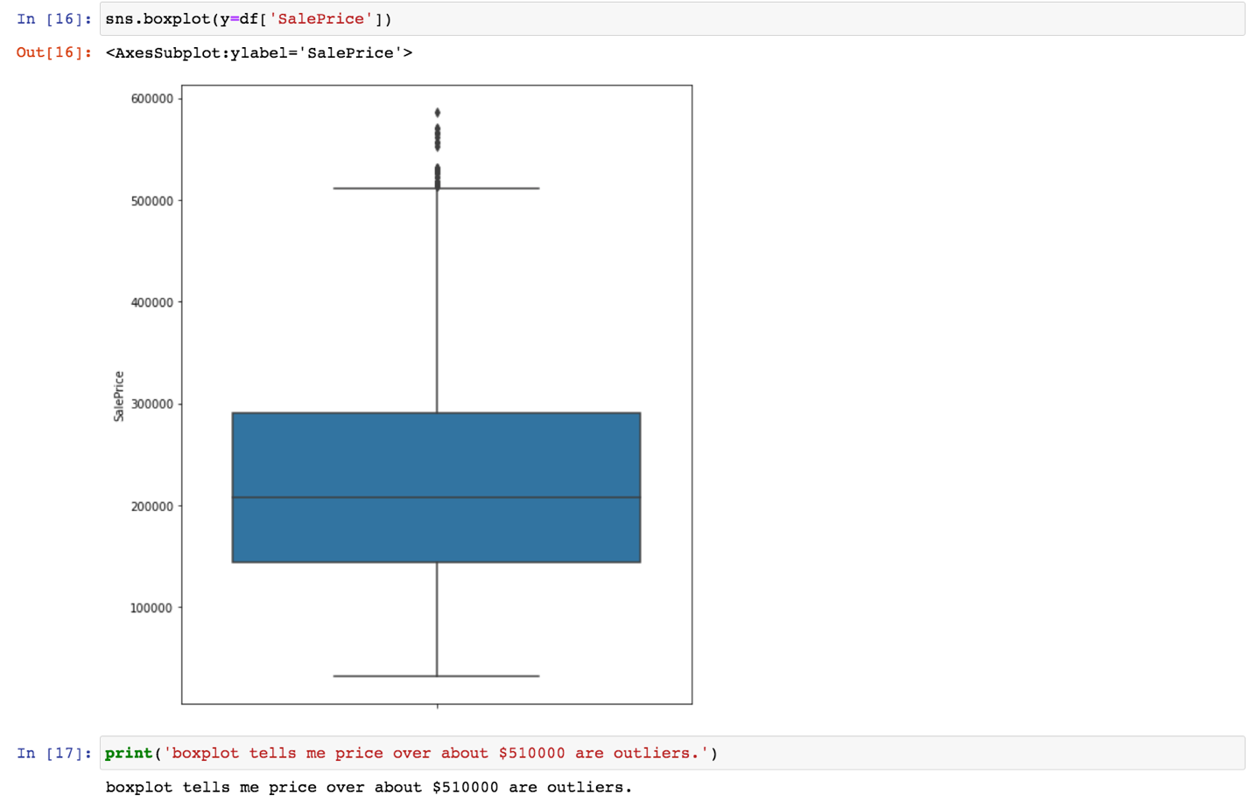



Thus, after dropping these highest values, we refit the new X and Y into the linear regression model. The updated result of RMSE is 38923, which is slightly better than before.

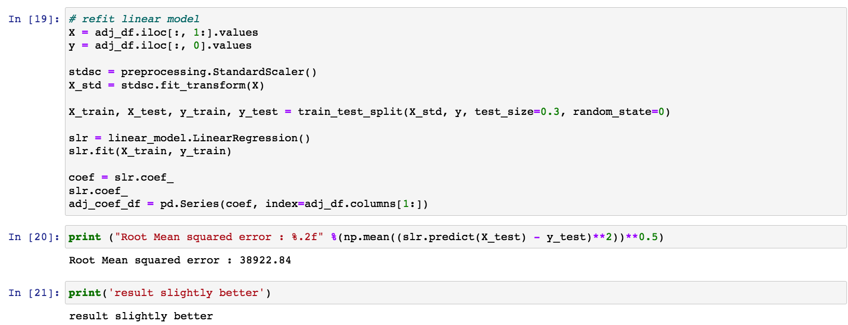

After removing outliers, we plotted the bar chart of 25 features’ coefficients. It is easy to see that three are six features having low coefficients, which are N_FacilitiesNearBy(Total), N_SchoolNearBy(High), N_SchoolNearBy(Middle), N_SchoolNearBy(Total), N_Parkinglot(Ground) and MonthSold. One weird thing is that number of elevators and number of parking(basement) have high coefficient. It doesn't make sense that people would so much care of number of elevators in apartment or number of parking space when they considering buy apartment. Therefore, we wanted to find out the reason why these two features have such high coefficients.

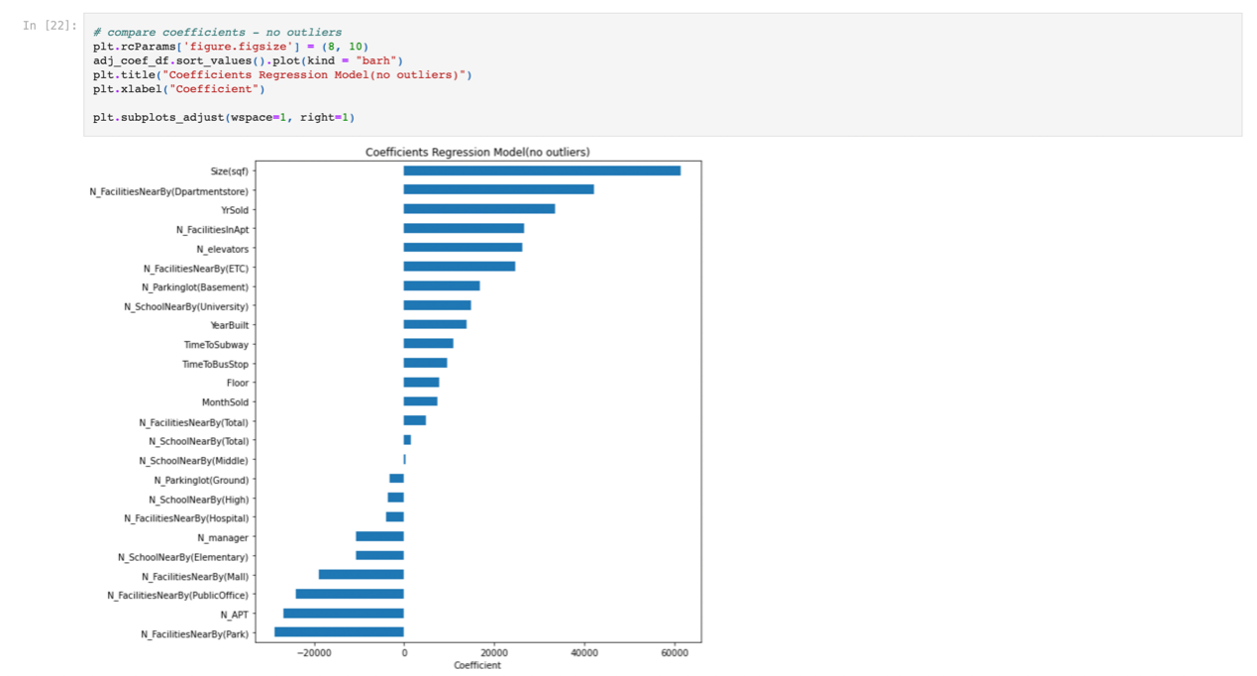



We believe that the more people stay in apartments, the more elevators are needed, so these two variables may have high correlations. The scatter diagram illustrates linear pattern between number of apartments and number of elevators.

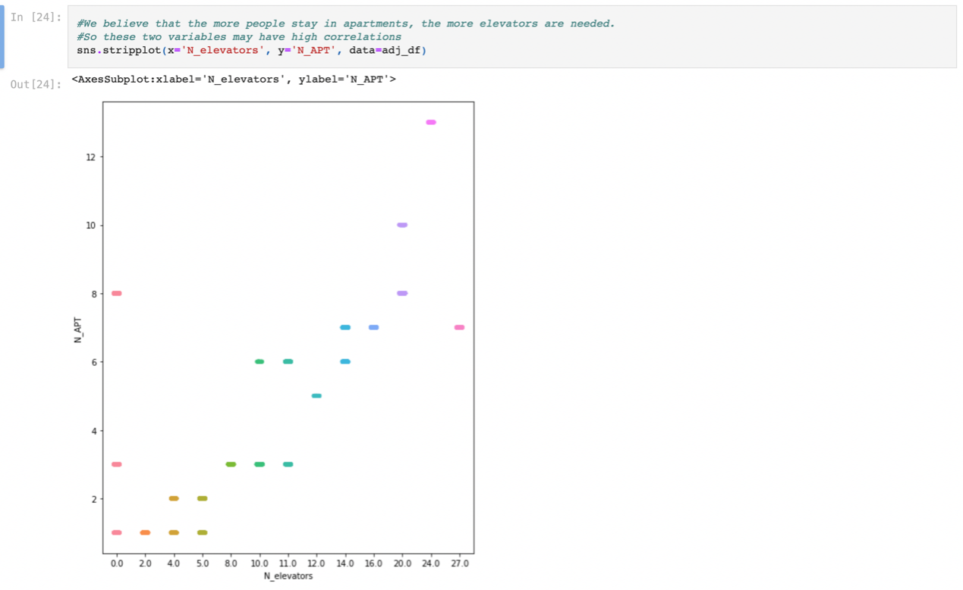

Similarly, we also believed that number of parking spaces and number of apartments may have linear relation. Therefore, we deleted number of elevators and number of parking spaces as they are highly correlated with number of apartments.

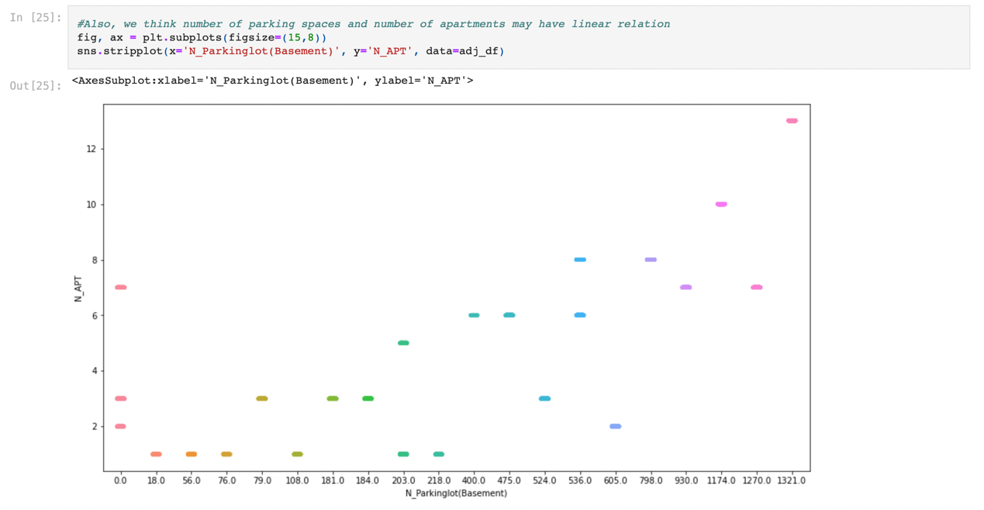

After deleting eight features, we fitted the model again. However, it is surprising that RMSE is even higher than before. This worse result indicates that model cannot predict well with fewer features. RMSE (about 40000) shows us that model cannot predict well. Therefore, for better result, next step is optimizing it!

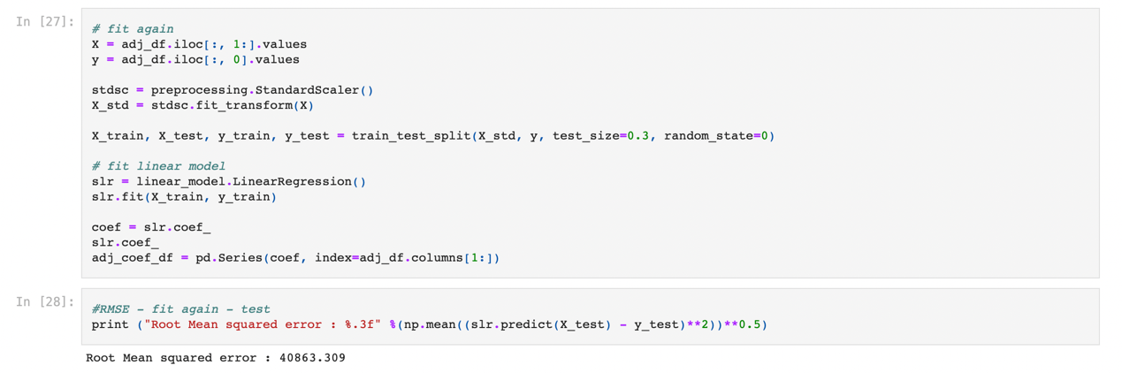

We used Gradient Boosting Regressor from sklearn to optimize it. After optimizing the model, its RSME becomes much smaller.

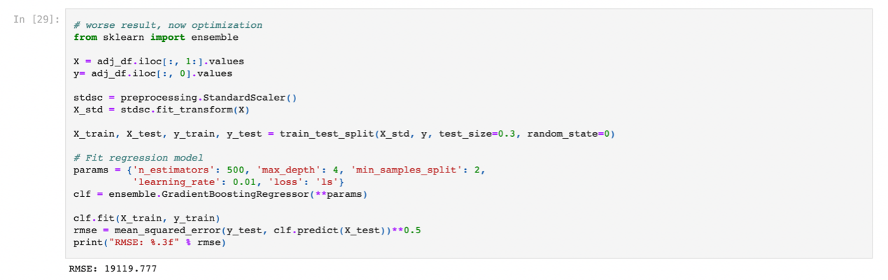

Loss diagram also illustrates that the model is better after 500 boosting interactions.

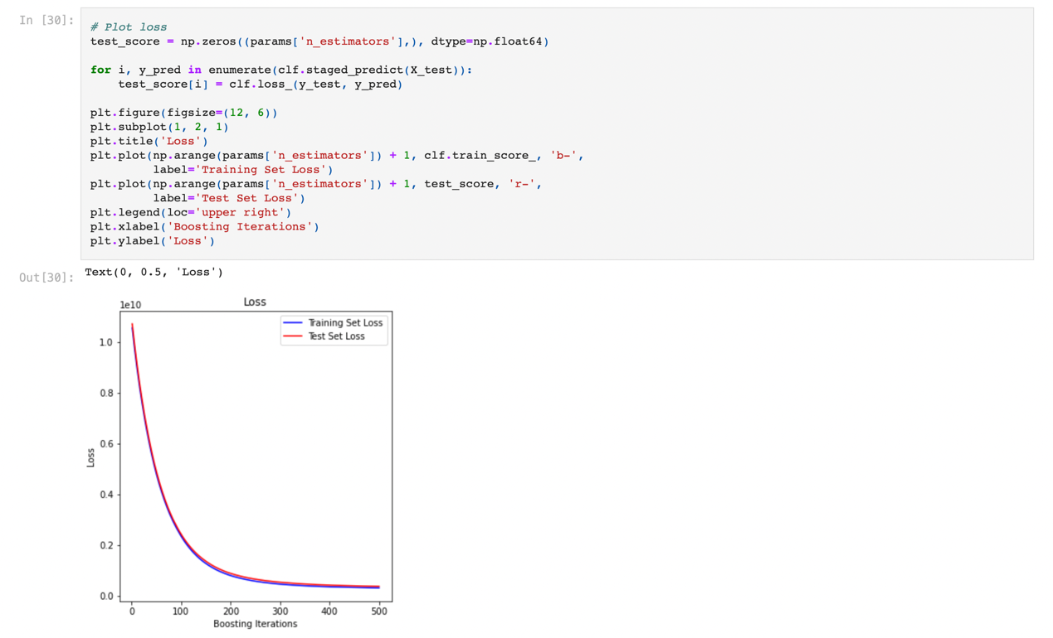

Next, we wanted to find out the most important features, so we plotted feature importance by making importance relative to max importance. From the variable importance bar chart, it is easy to figure out 6 most important features affecting on apartment price, which are Size(sqf), YrSold, YearBuilt, N_FacilitiesNearBy(ETC), N_FacilitiesInApt and N_APT.

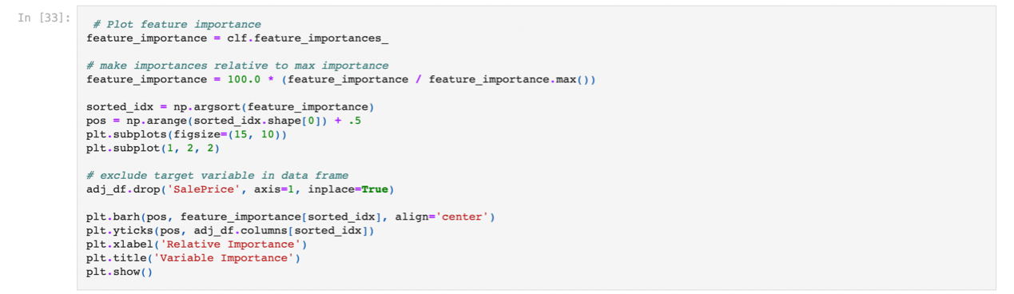

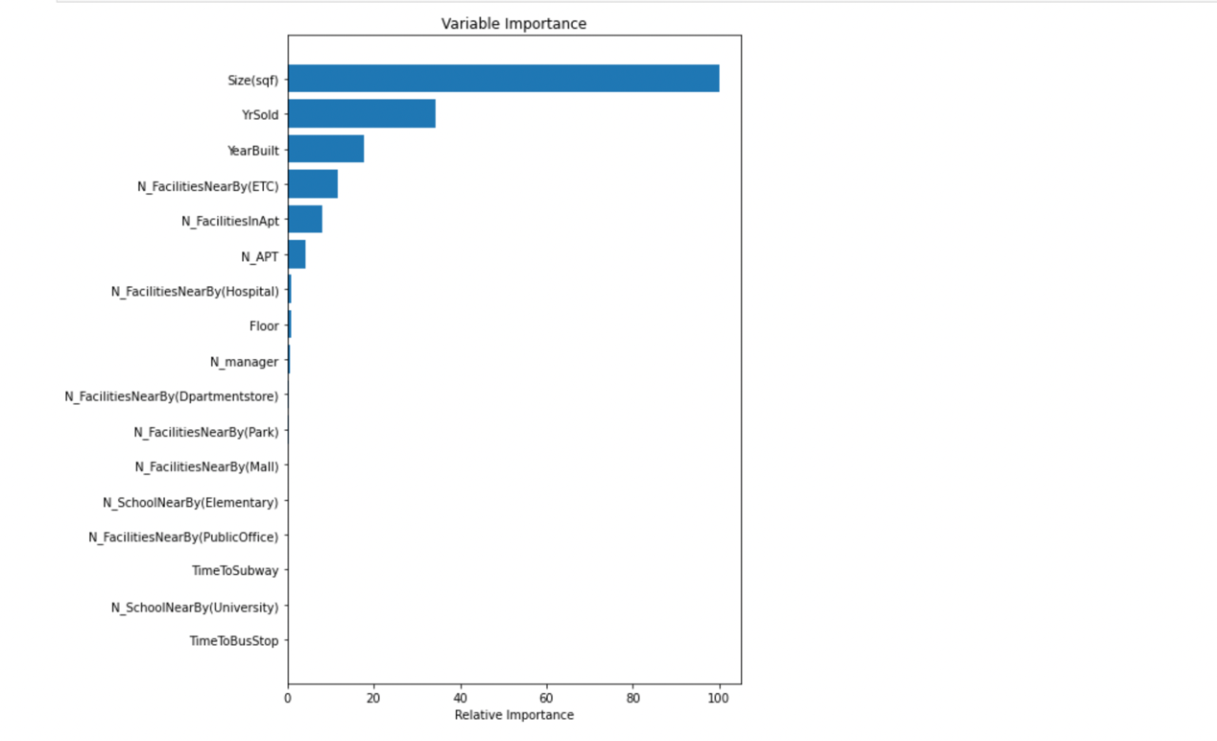

After cleaning data and finding the most important features, the next step is to find the best model. We will compare four models’ RMSE and R^2 to find the best one. These four models are Linear regression, KNN regression, Lasso and Ridge respectively.

We normalized X and split data into training set and testing set.

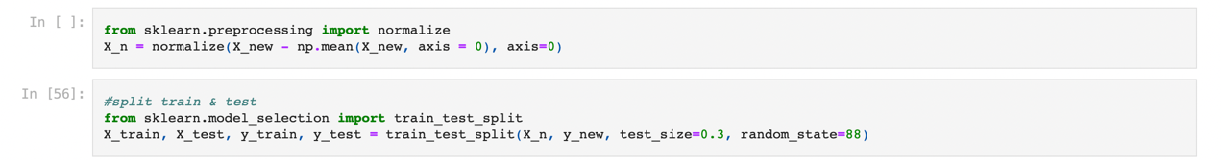

The first model we used is linear regression. Firstly, the whole set of X and y is used to fit the linear regression to calculate RMSEfit and R^2fit.

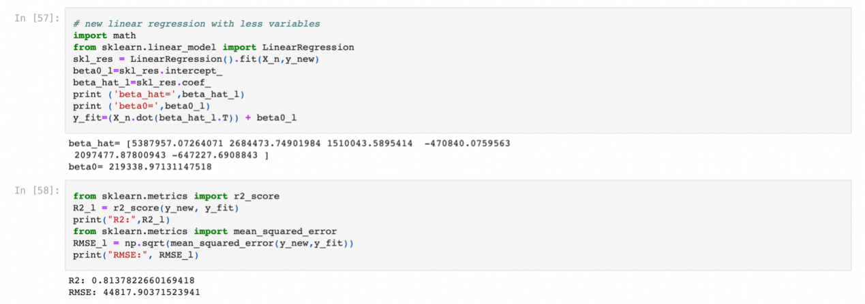

We normalized RMSEfit using RMSEfit divided by the average of all y values.



Then 10-fold cross validation is used to split the whole set of data into training set and test set, followed by working out E(RMSE test) and E(R^2 test).

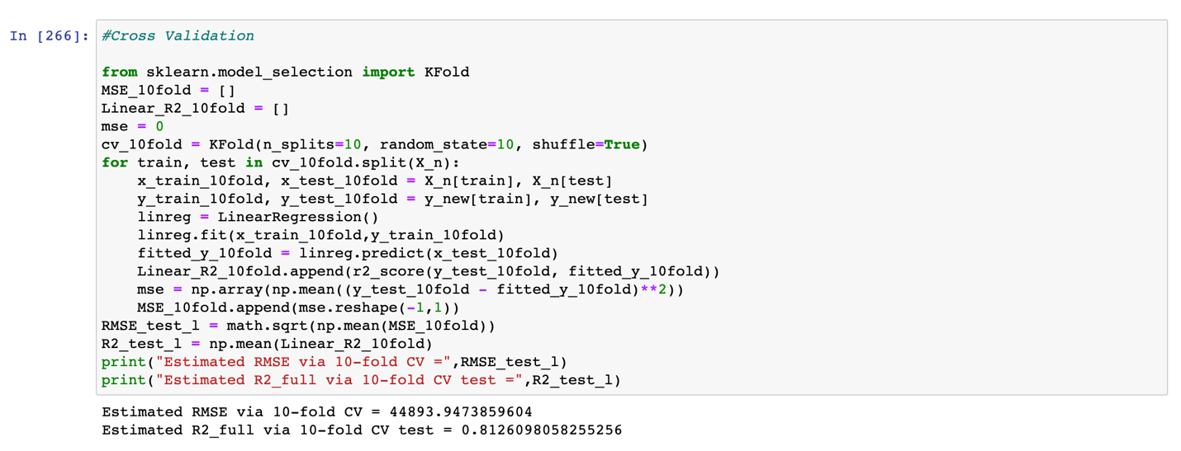

We normalized E(RMSE test) again.



We created 2 DataFrame to store our result, and then we used append method to insert the data.



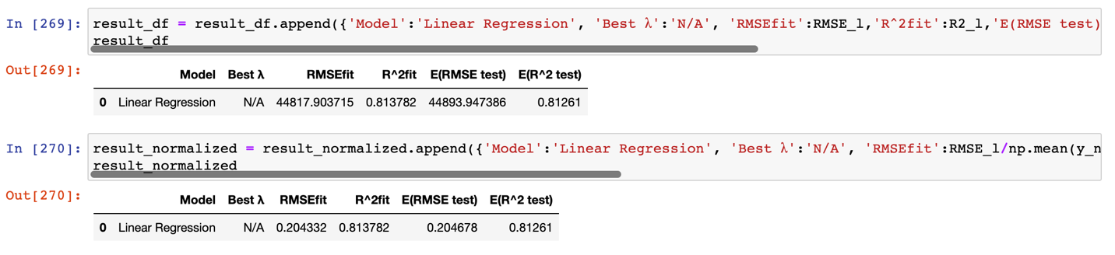

The second model we used is K neighbor regressor. First, we calculated the best number of K.

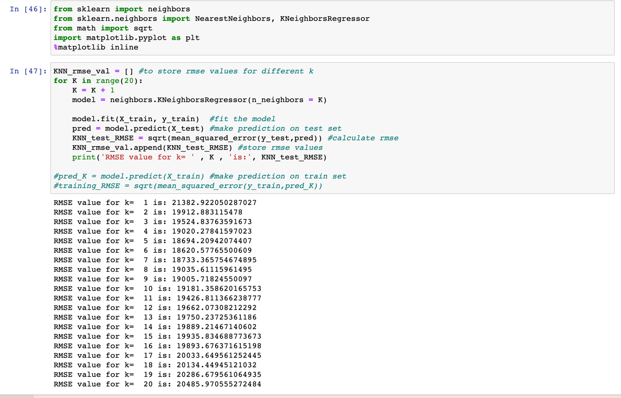

Then, we ploted the Ks with graph. The best RMSE we found is when K = 6.



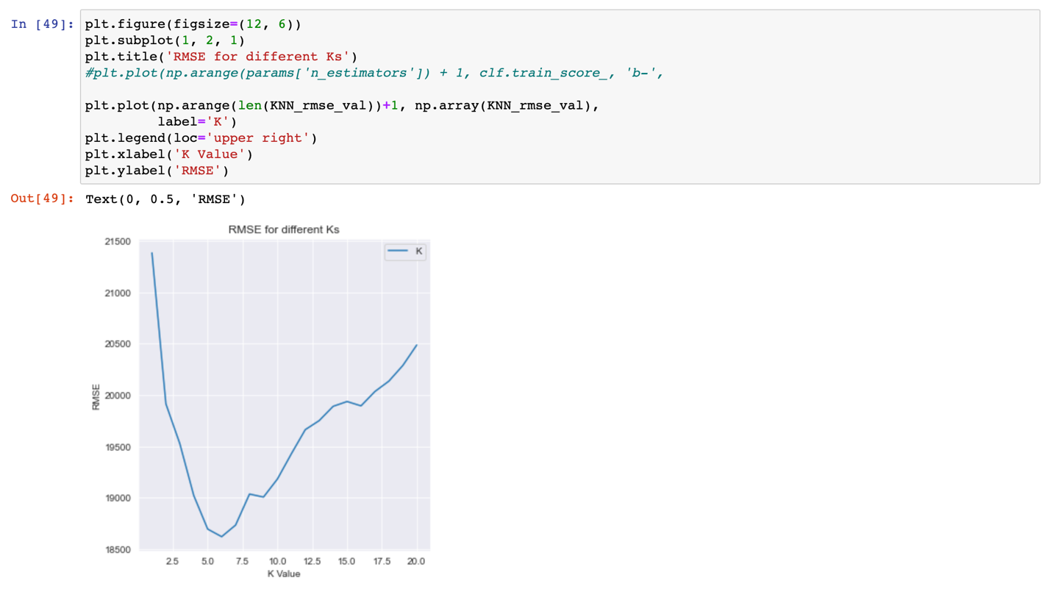



Using the best K, we fit the whole set of X and y to KNN regression to calculate RMSEfit and R^2fit.

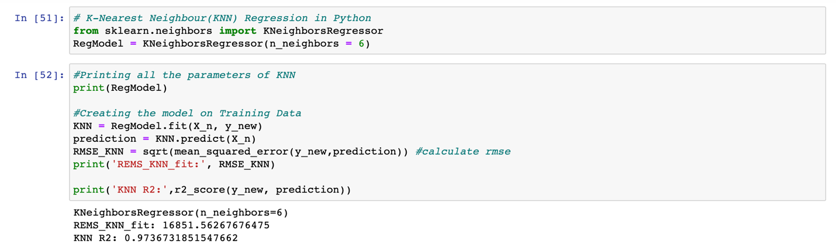

We normalized RMSEfit using RMSEfit divided by the average of all y values

Then, we used 10-vold cross validation as we used for linear regression to find E(RMSE test) and E(R^2 test). 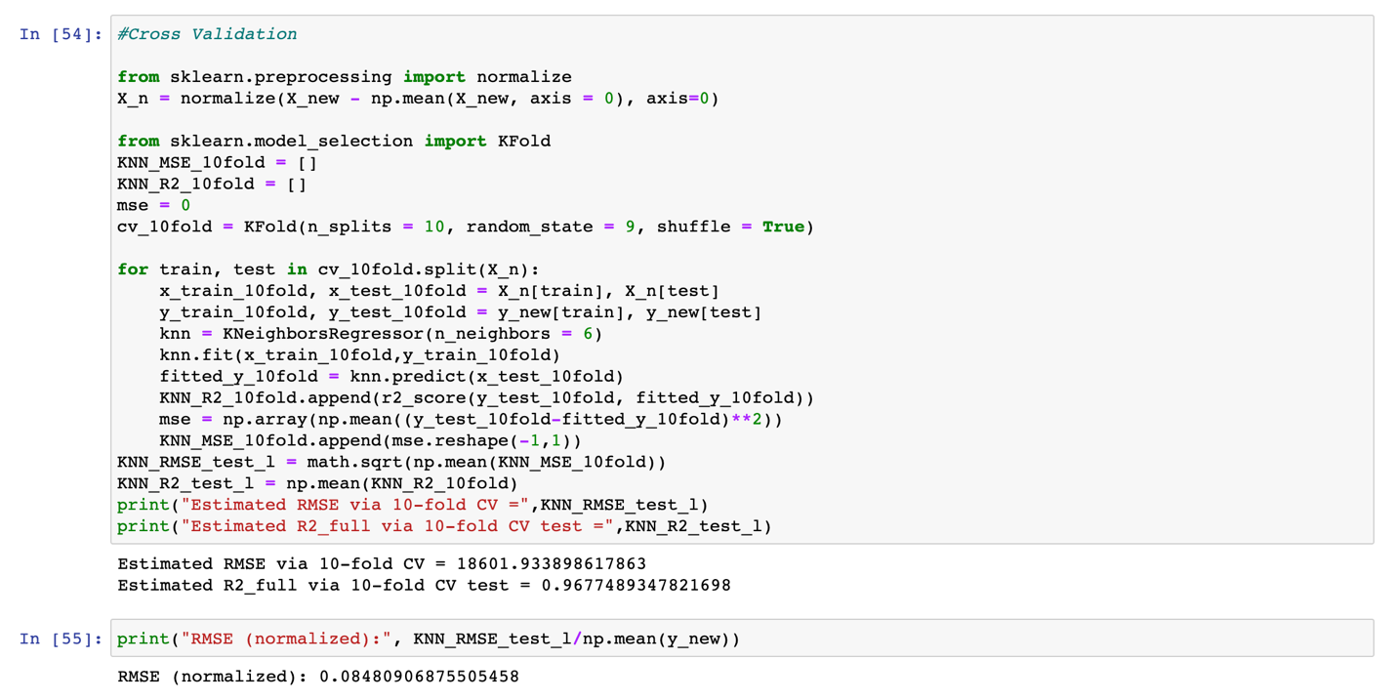

The E(RMSE test) for KNN we found after normalizing is better than linear regression. We append the result to our DataFrame.

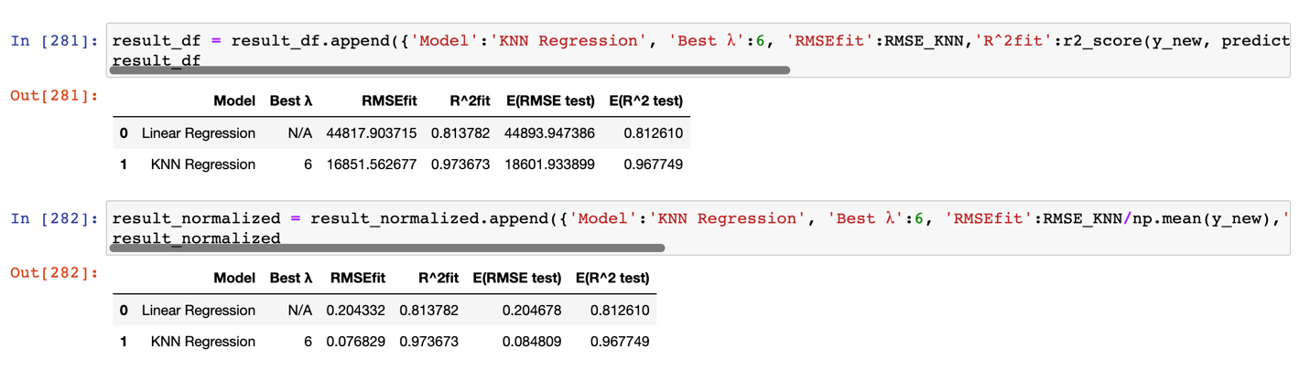

The thrid model we used is lasso regression. First, we calculated the best lambda. 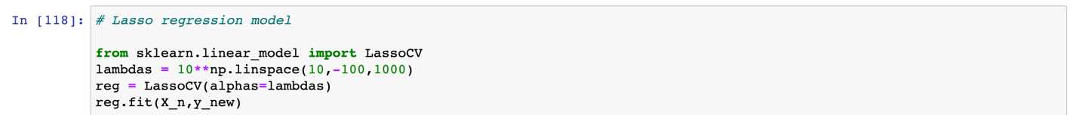

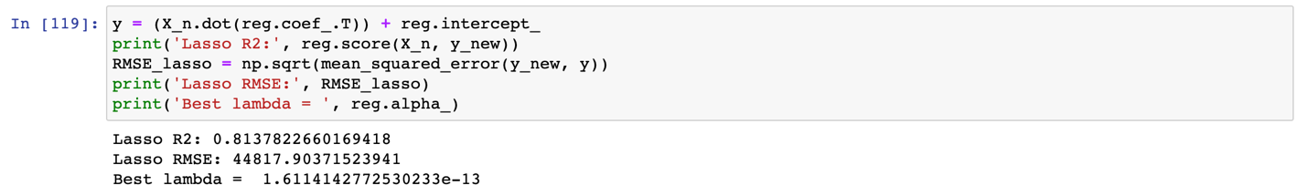

Using the best lambda, we fit the whole set of X and y to lasso regression to calculate RMSEfit and R^2fit.

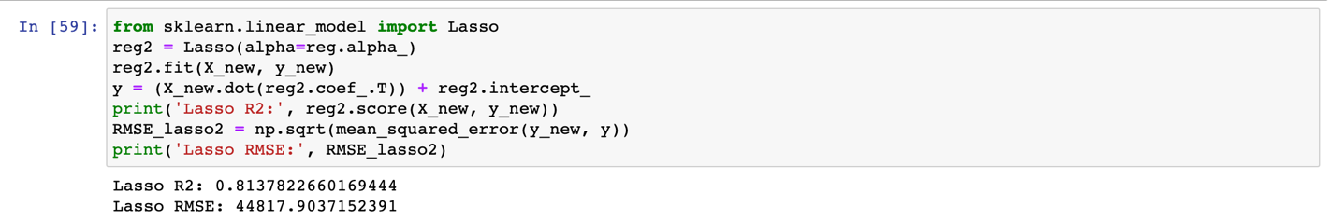

Then, we normalized the RMSEfit.

After that, we used 10-vold cross validation as we used for linear regression to find E(RMSE test) and E(R^2 test).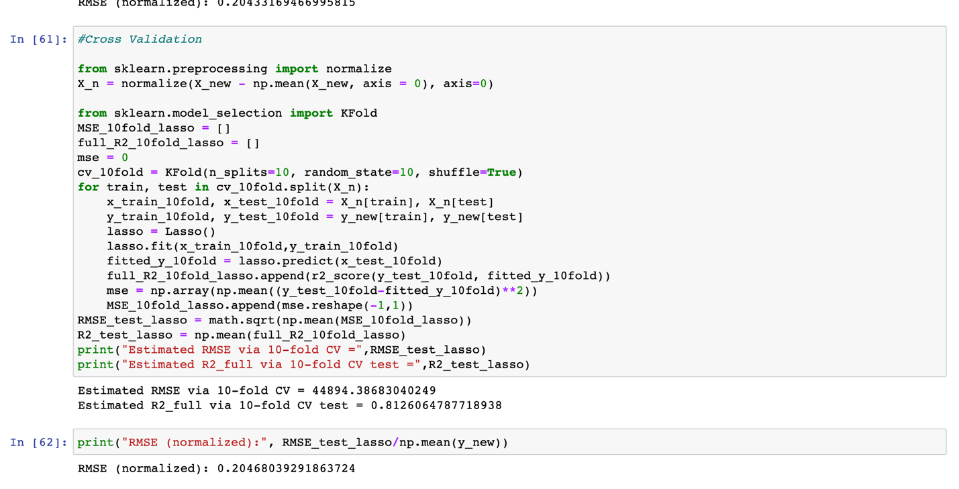

The E(RMSE test) for KNN we found after normalizing is similar to linear regression. We append the data again. The best lambda was too small so it was rounded to zero in the table.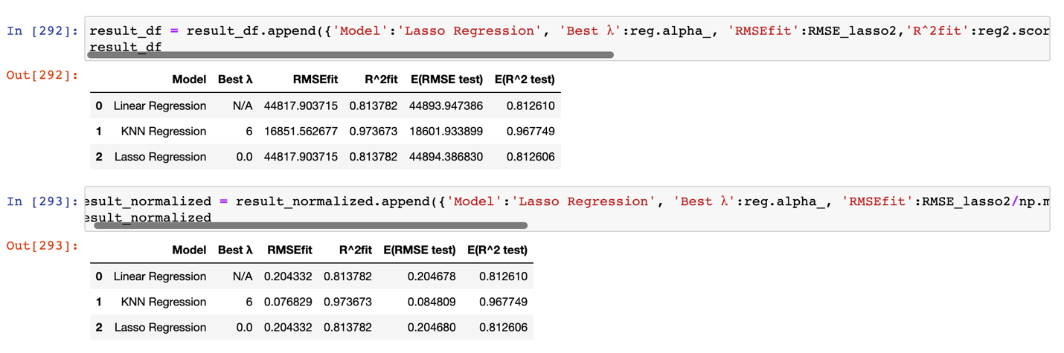

The forth model we used is ridge regression. First, we calculated the best lambda.

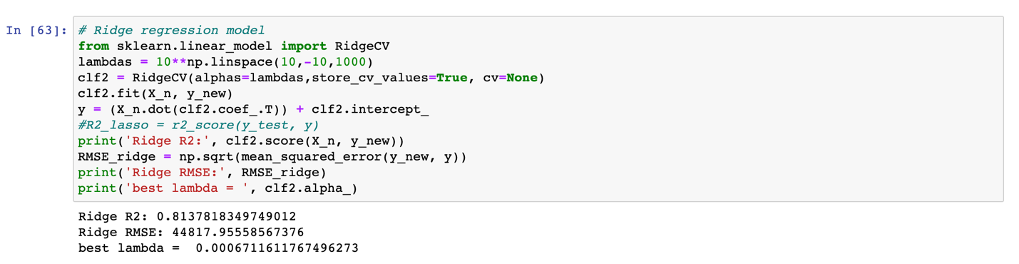

Using the best lambda, we fit the whole set of X and y to ridge regression to calculate RMSEfit and R^2fit. And we normalized RMSE.

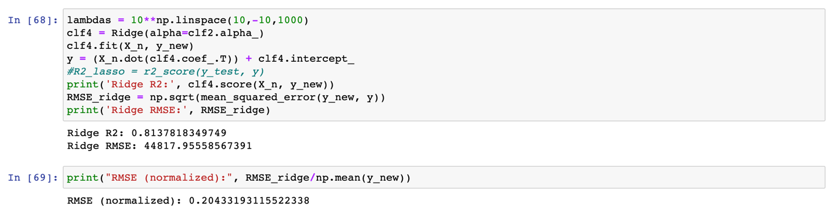

Then, we calculated E(RMSE test) and E(R^2 test) with 10-vold cross validation, and normalized the E(RMSE test).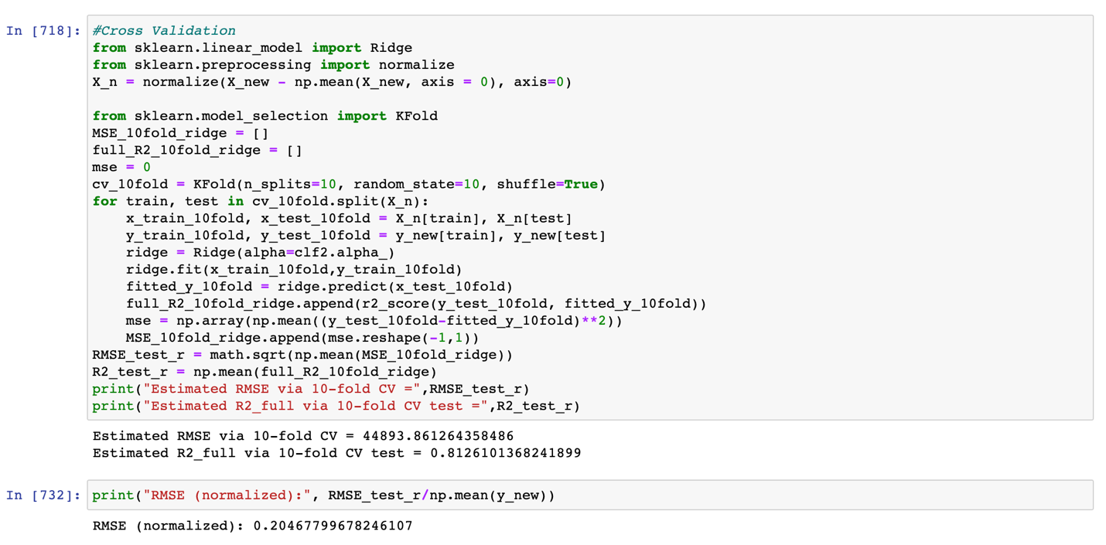

We insert the data to Dataframe.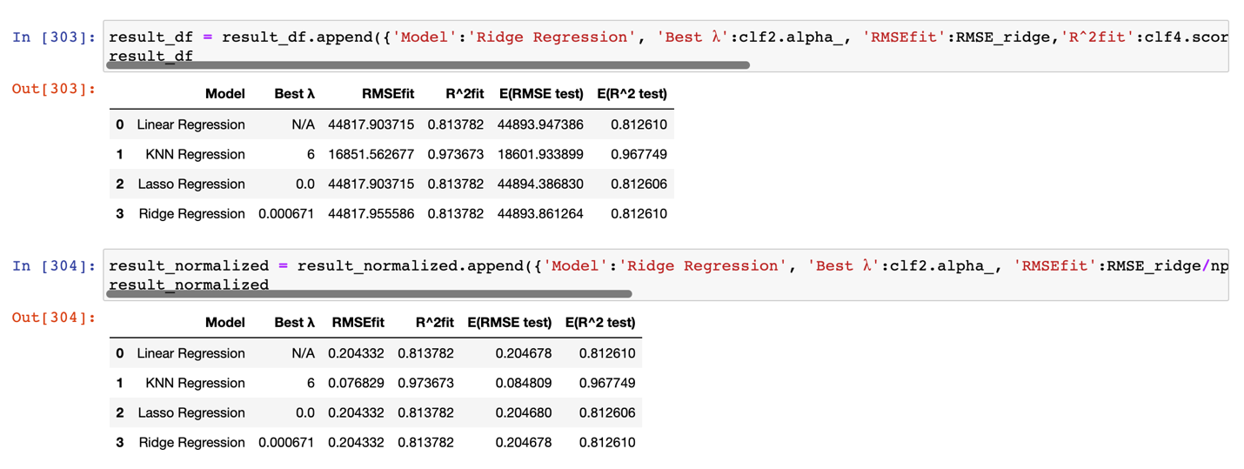

The result is similar to lasso regression.

The fifth model we used is decision tree model. We find the best number of depth with max_leaf_node.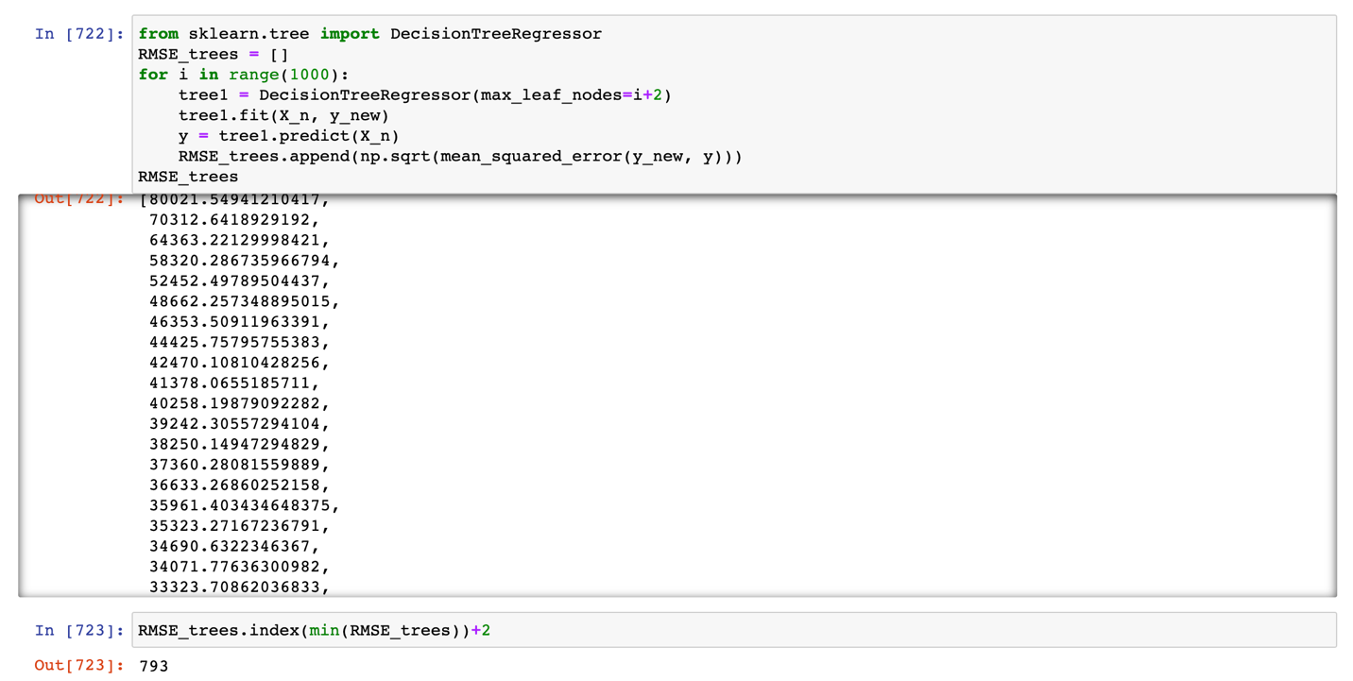

We fit the whole set of X and y to ridge regression to calculate RMSEfit and R^2fit. And we normalized RMSE. The found that the corresponding number of depth is 17. 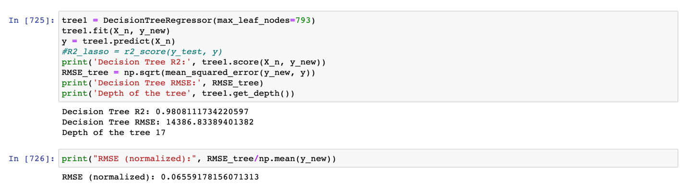

Then, we calculated E(RMSE test) and E(R^2 test) with 10-vold cross validation, and normalized the E(RMSE test).

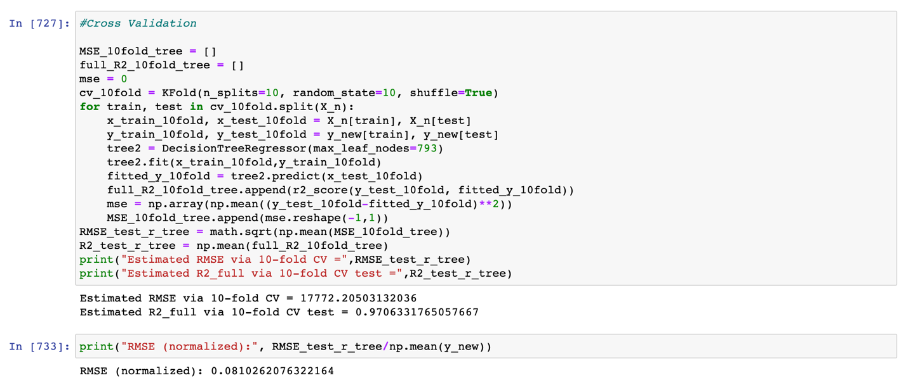

We insert the data to Dataframe.

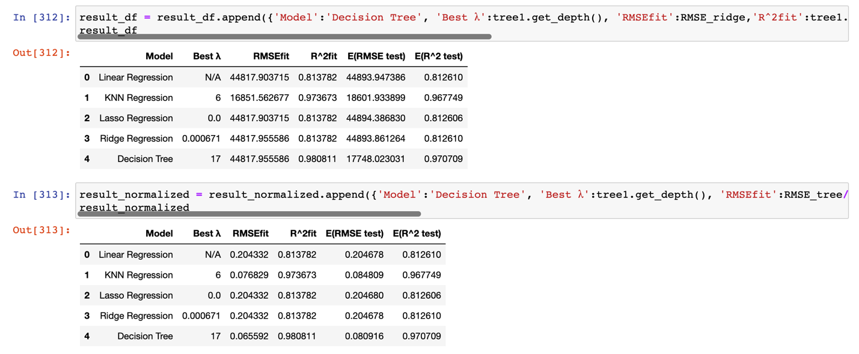

The result is much better than previous all models.

The last model we used is random forest model. We first use max_depth to find the best lambda.

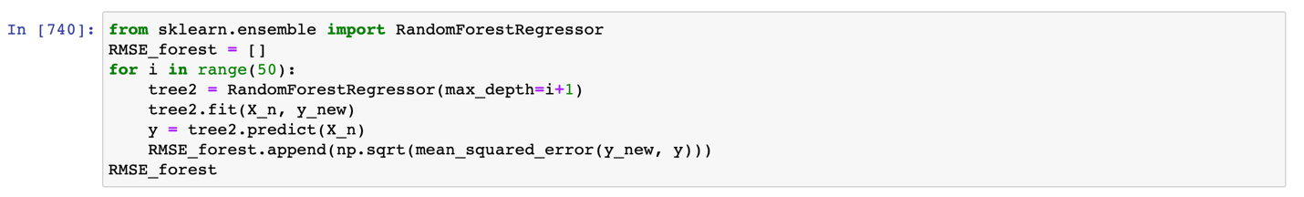



Then, we used the whole set of X and y to ridge regression to calculate RMSEfit and R^2fit. And we normalized RMSE.

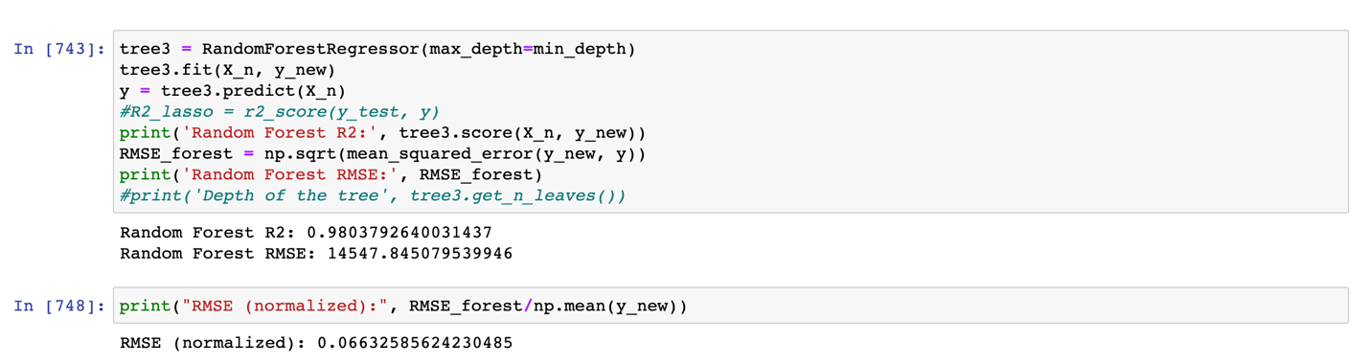

Then, we calculated E(RMSE test) and E(R^2 test) with 10-vold cross validation, and normalized the E(RMSE test).

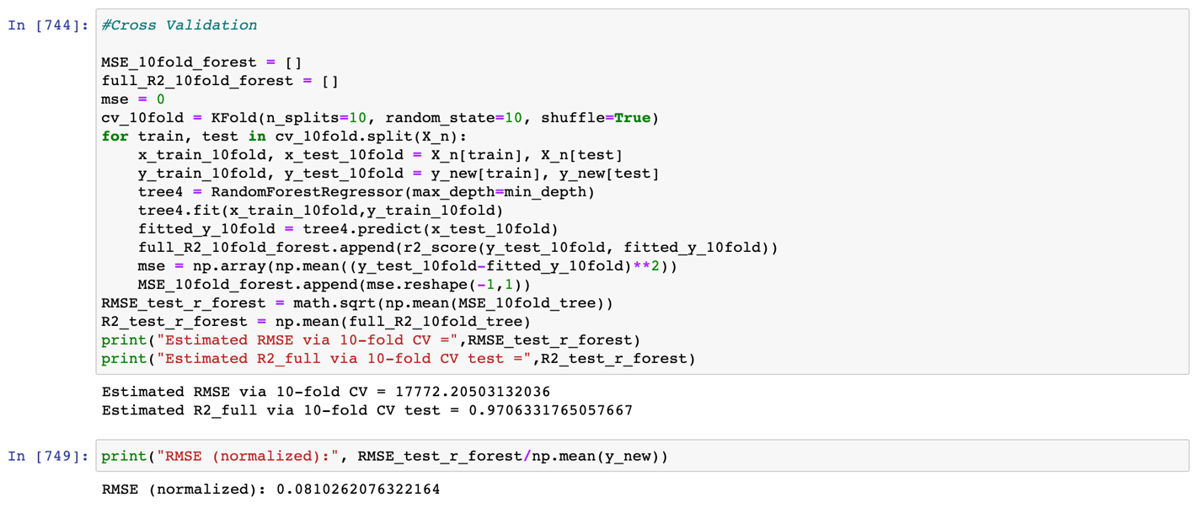

We insert the data to Dataframe.

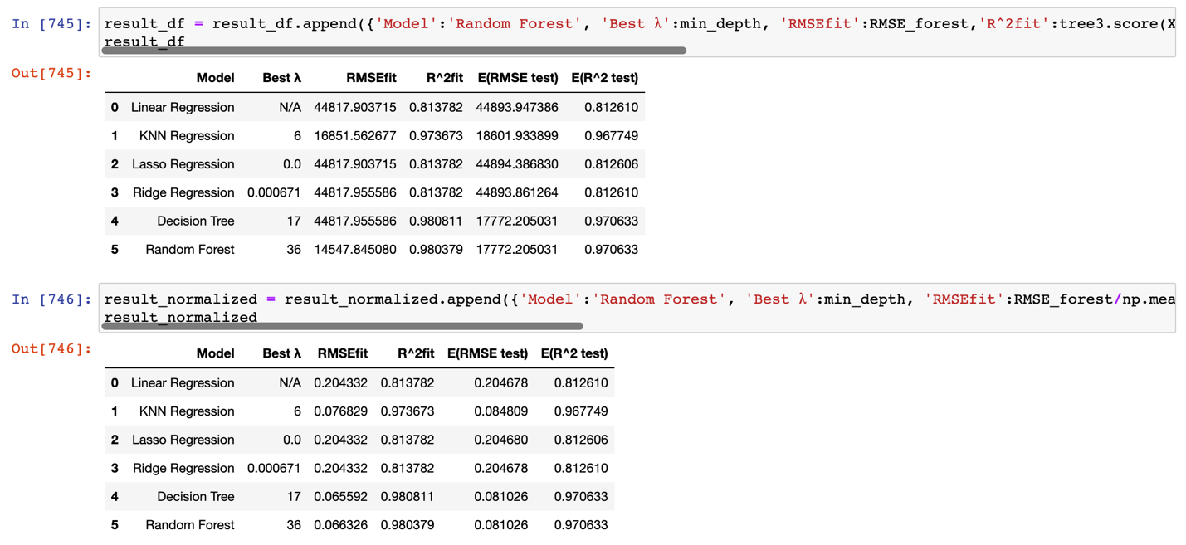

The result is similar to decision tree model.

Finally, we used the optimized RMSEfit and E(RMSE test) to create a bar graph to compare the result.

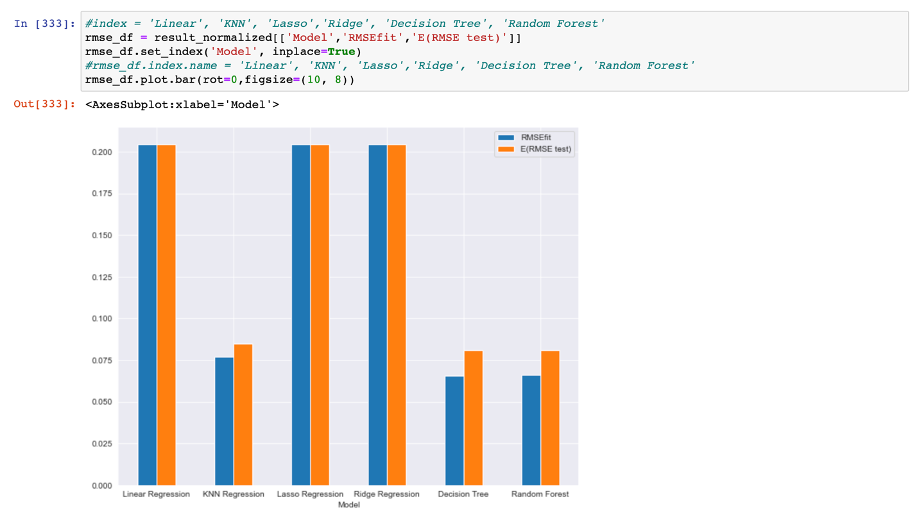

Overall, decision tree and random forest have the best performance, and KNN is the third. Compared to the three non-linear models, the three linear models, linear regression, lasso regresion, and ridge regression, do not perform as well.